

**TEXT BOX FOR PHOTO OF YOUR MACHINE FROM THE INTERNET- PASTE AS BITMAP OR INDEPENDENT BIT MAP-USE PASTE CLIPBOARD AT TOP LEFT OF MICROSOFT WORD- SELECT PASTE SPECIAL**

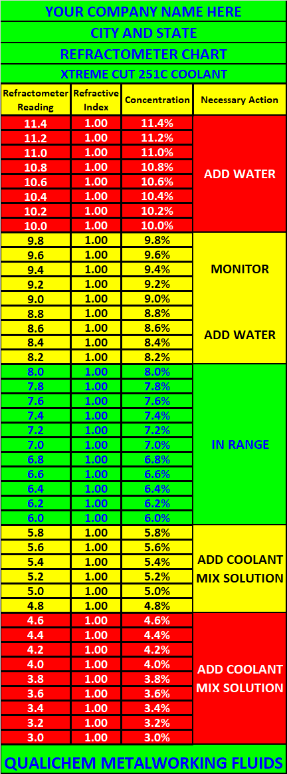**BOX AS PASTE SPECIAL AND AS A BITMAP OR INDEPENDENT BITMAP**

**ADJUST ACCORING TO THE TEXT BOX SIZE**

***PROBLEMS WITH THE COOLANT, CALL***

***YOUR QUALICHEM REP***

***CELL PHONE #***

***EMAIL ADDRESS***

***YOUR COMPANY NAME HERE***

***COOLANT CONTROL PLACARD***

***QUALICHEM XTREME CUT 251C***





*MACHINE BRAND: HAAS ST20Y TURNING CTR.*

*SUMP SIZE: 55 GALLONS*

*COOLANT PRODUCT: XTREME CUT 251C*

*REFRACT READING: 6.0 TO 8.0 (6.0% TO 8.0%)*

*GALS. TO CHARGE: 3.3– 4.4 GAL. (6.0%-8.0%)*

*GAL. TO RAISE 1%: 0.55 GAL.*

*OZ. TO RAISE 1%: 70 OUNCES*

*WAY OIL: ISO 68*

*HYDRAULIC OIL: ISO 46*